April 2026 Community Update: Jameson Road Landfill site

We are committed to keeping residents updated on the action being taken to address odour issues at the Jameson Road Landfill site. We understand the effect these odours can have on daily life, both inside homes and in outdoor spaces, and we are continuing to work towards a long-term solution.
Figures for April:
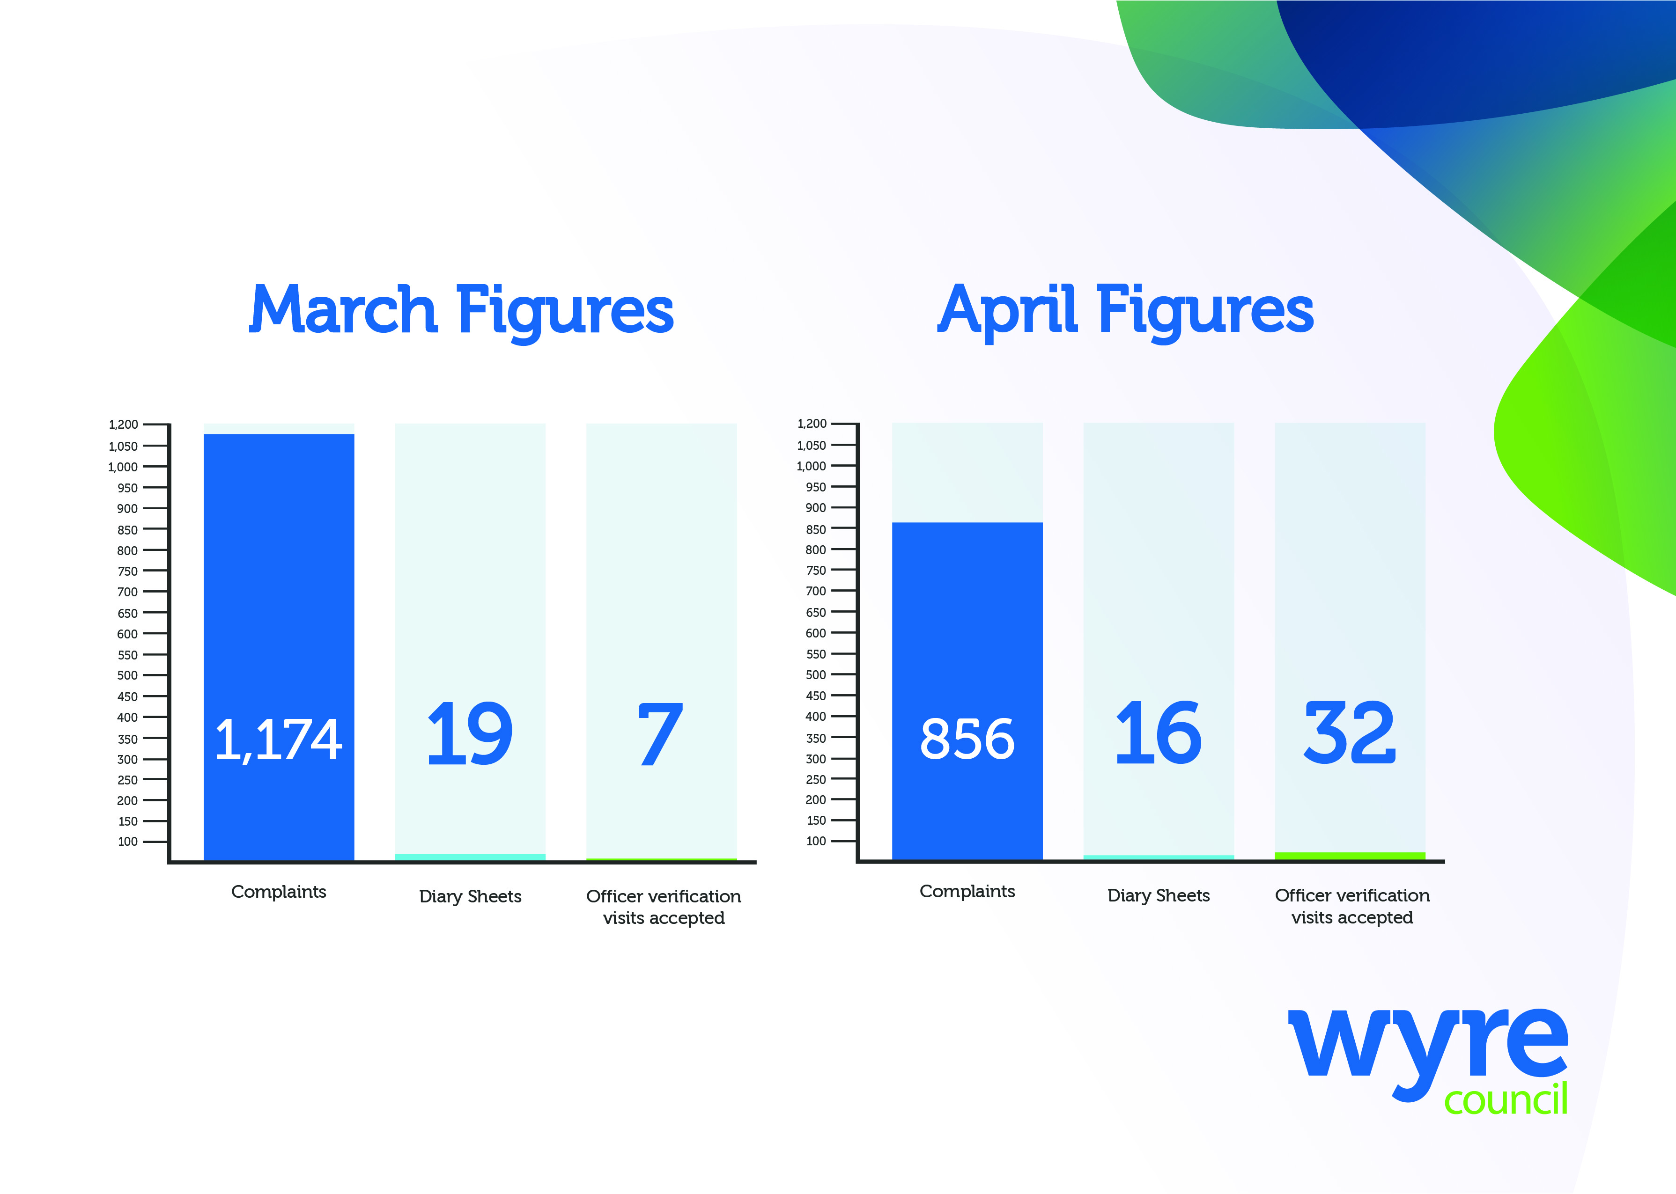
- In April we received and assessed 856 complaints related to the site.

- In total, we received 16 completed Odour Diary Sheets. Two were from businesses and 14 from four households.

- We offered those who sent in diary sheets the chance to have an officer carry out a verification visit at their property. A total of 32 visits were undertaken in April. Of these, four visits were made to one home and the remaining 28 to businesses in the area.

What else are we doing?

- Wyre Council issued an abatement order to Transwaste Recycling and Aggregrates Ltd on April 30. The notice legally requires the company to stop unwanted odour from impacting local residents in their homes and places of work within 60 days and to prevent its reoccurrence. This period of time is based upon legal advice and has been set in accordance with the requirements of the legislation, which stipulates that the operator must be given a ‘reasonable time period’ in which to comply.

- It is crucial that residents who are affected by unwanted odour continue to record these instances on diary sheets and report them to the Council. Now that the abatement notice is in force, it is even more important that high-quality evidence is collected and submitted. Maintaining accurate records enables the council to monitor compliance effectively and ensures that any ongoing issues can be addressed promptly and in accordance with legal requirements.

- We met with the Environment Agency in relation to a regulatory enforcement notice it served upon Transwaste in January. This requires the operator to ensure that Cell 5 and Cell 6 are adequately covered to reduce the risk of odour.

- The council issued a Default Notice to Transwaste in relation to its lease in February. Wyre Council is monitoring the situation closely to ensure the site operator meets its lease obligations while it reviews the next steps in the process.

We need your help
Wyre Council is working to pursue a case of statutory nuisance on behalf of residents.
We can only do this with your help...
Please follow these three steps to make your experience count in this investigation:
- Complete Odour Diary Sheets
You should include:
- when and how long you were impacted
- where in your home you smelt the odour
- how strong it was and how it affected you
Continue recording this information as long as you are affected and submit the completed sheets regularly - every 7 or 14 days.
On days when there is no odour, please write this down too.
Complete a diary sheet here: https://www.wyre.gov.uk/jamesonroad

- Send completed sheets back to Wyre Council
You can return completed sheets by:
Email: JamesonRoadLandfill@wyre.gov.uk
Post: Environmental Protection, Wyre Council, Civic Centre, Breck Road, Poulton-le-Fylde, Lancashire, FY6 7PU
In person: Drop them off at reception at the Civic Centre or to the dedicated post box at Fleetwood Market

- Accept an officer verification visit
These are essential if we are to take a strong case forward for statutory nuisance.
Ideally, these visits should take place in the part of your home where you are most affected and which your diary evidence covers. However, if accessing your home is not convenient, we can sometimes conduct the visit in your garden or another suitable outdoor area.

Community Liaison Group

The next meeting will take place on Friday, May 15.

Please visit the website to join our mailing list to receive notifications when updates or new information is available: www.wyre.gov.uk/Jamesonroad

