February 2026 Community Update: Jameson Road Landfill site

We remain dedicated to keeping residents up to date with the ongoing measures we are taking to address odour issues at the Jameson Road Landfill site. We recognise the impact that these odours can have on your everyday life, whether indoors or in your gardens, and are actively working towards a long-term resolution.
Figures for February:
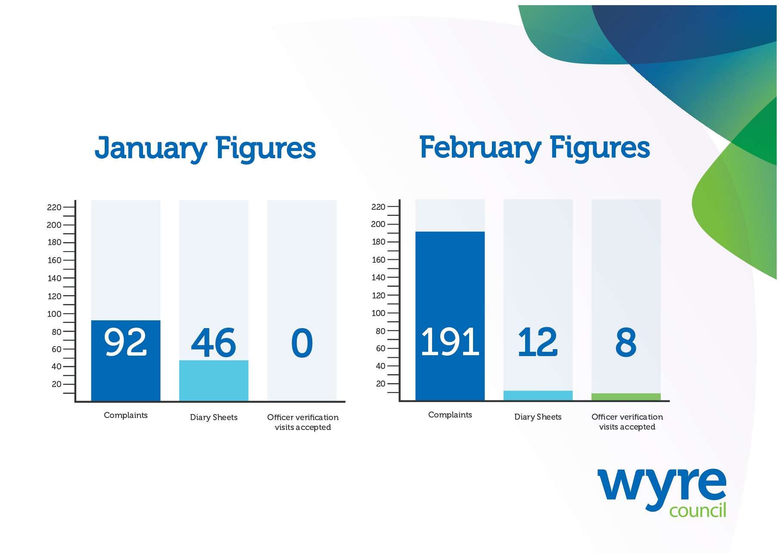
- In February we received and assessed 191 complaints related to the site.

- We received 12 completed Odour Diary Sheets from 4 households and 1 business. 5 related to incidents of unwanted odour in January.

- We offered residents who sent in diary sheets the chance to have an officer carry out a verification visit at their property. A total of 8 visits were undertaken in homes in January.

We need your help
Wyre Council is actively pursuing a case of statutory nuisance on behalf of residents affected by unwanted odour.
To do this, we must gather evidence to the level required to present a strong case in court. We can only do this with your help...
There are three steps to make your experience count in this investigation:
- Complete Odour Diary Sheets
You should include:
- when and how long you were impacted
- where in your home you smelt the odour
- how strong it was and how it affected you
Continue recording this information as long as you are affected and submit the completed sheets regularly - every 7 or 14 days.
On days when there is no odour, please write this down too.
Complete a diary sheet here: Diary sheets – Wyre Council

- Send completed sheets back to Wyre Council
You can return completed sheets by:
Email: JamesonRoadLandfill@wyre.gov.uk
Post: Environmental Protection, Wyre Council, Civic Centre, Breck Road, Poulton-le-Fylde, Lancashire, FY6 7PU
In person: Drop them off at reception at the Civic Centre or to the dedicated post box at Fleetwood Market

- Accept an officer verification visit
These are essential if we are to take a strong case forward for statutory nuisance.
Ideally, these visits should take place in the part of your home where you are most affected and which your diary evidence covers. However, if accessing your home is not convenient, we can sometimes conduct the visit in your garden or another suitable outdoor area.

What else are we doing?

- We trialed an enhanced monitoring exercise with a group of residents who had regularly completed and submitted diary sheets covering at least seven consecutive days to report unwanted odour inside their homes.

- Regular meetings with the Environment Agency regularly took place. We understand the agency served a regulatory enforcement notice on Transwaste on January 30 which required the operator to ensure that areas of the landfill (Cell 5 and Cell 6) are adequately covered to reduce the risk of odour. The Environment Agency confirmed the operator had made positive progress on the covering of the cells 5 & 6 and aim to complete permanent capping.

- As the landlord of the Jameson Road Landfill site, Wyre Council issued a default notice to Transwaste regarding the lease it holds. This action was taken in response to the regulatory enforcement notice served by the Environment Agency, which required improved management and adequate covering of the landfill cells to reduce odour emissions. The default notice reflects the council’s commitment to ensuring compliance with lease obligations and safeguarding the interests of local residents.

Community Liaison Group

A meeting of the Community Liaison Group took place on February 27. The key discussion points are summarised here:

- The group was updated that the overall report is nearing completion and will comprise three key elements: the UKHSA health risk assessment, the NHS data contribution (now concluded), and the findings from the community engagement survey. It is anticipated that a draft version of the full report will be available by the end of March.

- Cell 6 is now nearing full capacity, and work is underway to prepare it for the capping process, which will serve as a key step in closing and restoring this part of the site. Work had stopped on Cell 7 until the weather improves though this is likely to get underway in March. Cell 8 design work had started and this will be final cell.

- A first round of applications for the Community Benefit Fund closed in January. A total of 5 had been submitted. These were being assessed with grants expected to be awarded to successful applicants at the end of March. The closing date for the next round of applications is 8th July.

- The Environment Agency reported that high volumes of odour reports were received in January and February. EA inspections found inadequate cover on waste cells which had resulted in an enforcement notice requiring additional measures to reduce emissions.

- The representative from the Environment Agency said that although they do not intend to close the site, they expect better management to prevent recurring high-odour periods as cells near completion and will be reviewing this over the coming weeks.

- Wyre Council confirmed the number of complaints had increased in January and February. The council is continuing to work with residents to gather the evidence required as part of a statutory nuisance investigation.

- An enhanced monitoring exercise had been undertaken including 24/7 office cover to respond to reports of unwanted odour inside the homes of a group of residents who regularly submit diary sheets. There is a plan to repeat this notice in the future.

- A representative from Lancashire County Council reported that monitoring has been completed and a report produced. The assessment focused on the final levels and contours of Cell 6, which are now close to their approved limits. Once capped and covered with soil, the final height will be around 30 metres, with an expected settlement of 4–5 metres over time.

The next meeting will take place on Friday 24th April.

Please visit the website to join our mailing list to receive notifications when updates or new information is available: www.wyre.gov.uk/Jamesonroad

