January 2026 Community Update: Jameson Road Landfill site

We remain dedicated to keeping residents up to date with the ongoing measures we are taking to address odour issues at the Jameson Road Landfill site. We recognise the impact that these odours can have on your everyday life, whether indoors or in your gardens, and are actively working towards a long-term resolution.
Figures for January:
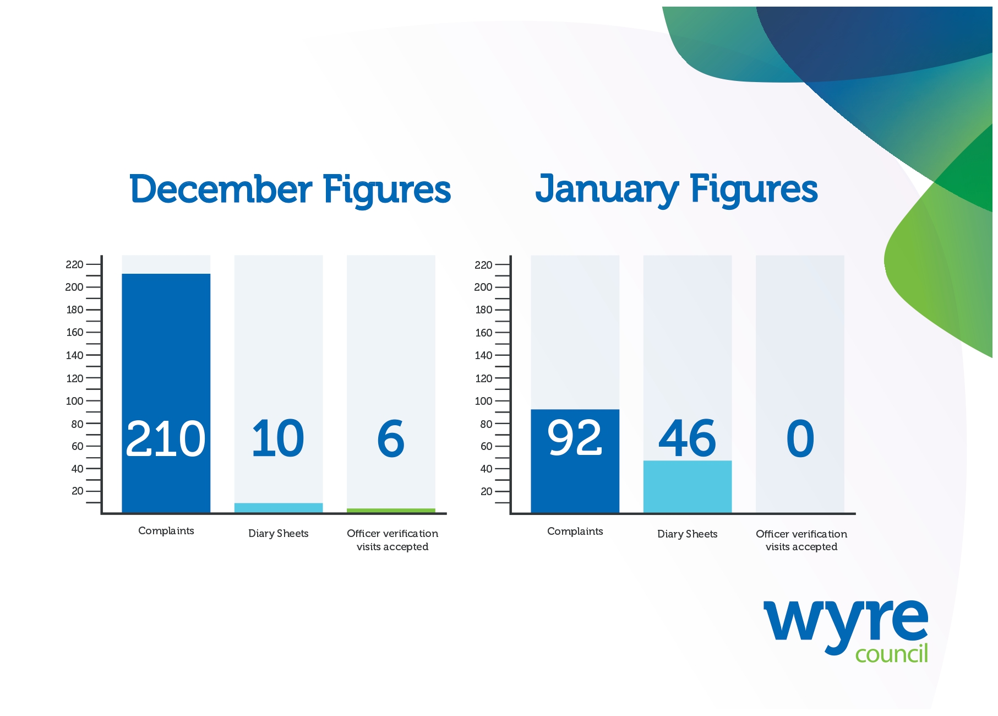
- In January we received and assessed 92 complaints related to the site.

- We received 46 completed Odour Diary Sheets from four households. 10 related to incidents of unwanted odour in January.

- We offered residents who sent in diary sheets the chance to have an officer carry out a verification visit at their property. No visits were undertaken in January.

We need your help
Wyre Council is actively pursuing a case of statutory nuisance on behalf of residents affected by unwanted odour.
To do this, we must gather evidence to the level required to present a strong case in court. We can only do this with your help...
There are three steps to make your experience count in this investigation:
- Complete Odour Diary Sheets
You should include:
- when and how long you were impacted
- where in your home you smelt the odour
- how strong it was and how it affected you
Continue recording this information as long as you are affected and submit the completed sheets regularly - every 7 or 14 days.
On days when there is no odour, please write this down too.
These are available here: Diary sheets – Wyre Council

- Send completed sheets back to Wyre Council
You can return completed sheets by:
Email: JamesonRoadLandfill@wyre.gov.uk
Post: Environmental Protection, Wyre Council, Civic Centre, Breck Road, Poulton-le-Fylde, Lancashire, FY6 7PU
In person: Drop them off at reception at the Civic Centre or to the dedicated post box at Fleetwood Market

- Accept an officer verification visit
These are essential if we are to take a strong case forward for statutory nuisance.
Ideally, these visits should take place in the part of your home where you are most affected and which your diary evidence covers. However, if accessing your home is not convenient, we can sometimes conduct the visit in your garden or another suitable outdoor area.

What else are we doing?

- We met with residents to discuss their experiences of unwanted odour. We discussed the evidence gathering process and why diary sheets and officer verification visits are key elements of the legal process that governs cases of statutory nuisance.

- We reviewed and revised our webpages on Jameson Road Landfill to make the process of evidence gathering easier to follow for all residents.

- We met with the Environment Agency regularly in relation to their day-to-day monitoring of the site during an increase in complaints. We understand the agency increased the number of visits to the site, completed assessments by a landfill gas technical specialist and use of a drone.

- We have the use of a specialist piece of equipment called a Jerome monitor for verification visits. Readings can be used in addition to crucial officer evidence to support a case of statutory nuisance.

Community Liaison Group

The next meeting will take place on Friday 27th February.

Please visit the website to join our mailing list to receive notifications when updates or new information is available: www.wyre.gov.uk/Jamesonroad

