October Community Update: Jameson Road Landfill site

We remain dedicated to keeping residents up to date with the ongoing measures we are taking to address odour issues at the Jameson Road Landfill site. We recognise the impact that these odours can have on your everyday life, whether indoors or in your gardens, and are actively working towards a long-term resolution.
Figures for October
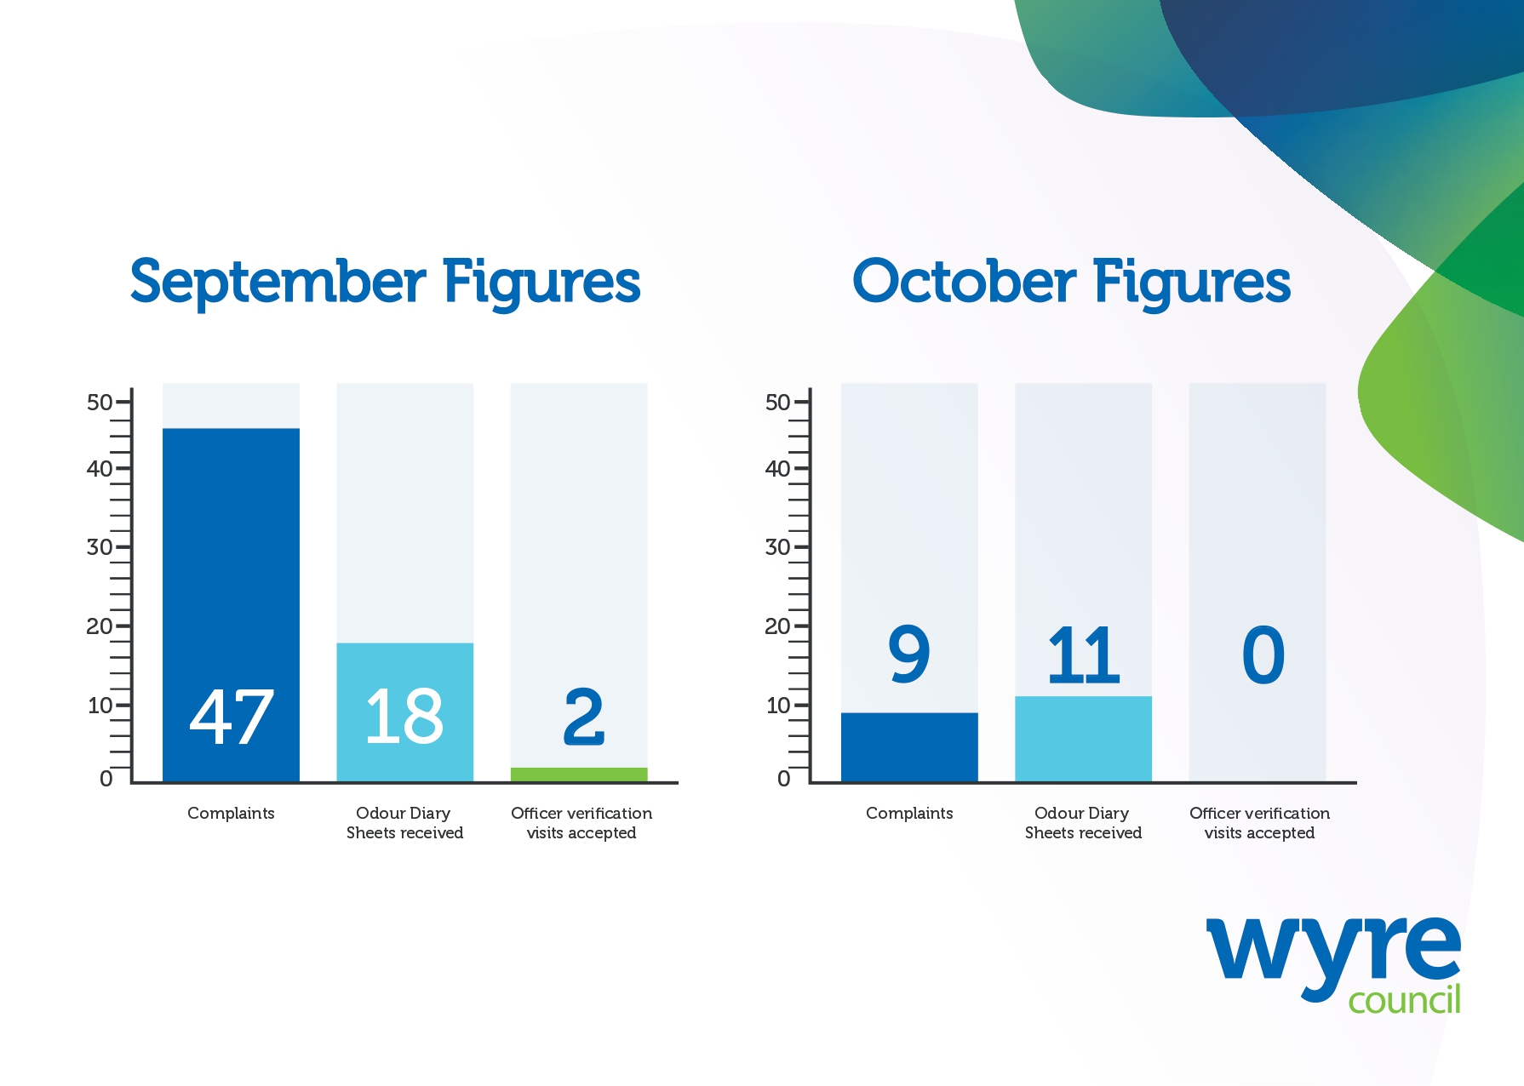
- In October, we received and assessed 9 complaints related to the site.

- We received 11 completed Odour Diary Sheets – a decrease from 18 in September.

- We offered residents who sent in diary sheets the chance to have an officer carry out a verification visit at their property. No residents took up this offer in October

- Please remember - we need your help to fully demonstrate the impact of odours on residents and to take appropriate legal action. Your participation is therefore essential in helping us address this issue effectively.

We need your help
Wyre Council is actively pursuing a case of statutory nuisance on behalf of residents affected by unwanted odour.
To do this, we must gather evidence to the level required to present a strong case in court. We can only do this with your help...
There are three steps to make your experience count in this investigation:
- Complete Odour Diary Sheets
Fill this in every day for seven days – including when and where in your home you smelt the odour, how strong it was and how it affected you.
These are available here www.wyre.gov.uk/JamesonRoad

- Send completed sheets back to Wyre Council
You can return completed sheets by:
Email: JamesonRoadLandfill@wyre.gov.uk
Post: Environmental Protection, Wyre Council, Civic Centre, Breck Road, Poulton-le-Fylde, Lancashire, FY6 7PU
In person: Drop them off at reception at the Civic Centre or to the dedicated post box at Fleetwood Market

- Accept an officer verification visit
It is important to highlight that officer verification visits do not require officers to enter your home at all; these visits can be fully conducted from your garden or any outside space, ensuring your privacy and comfort are respected at all times.

What else are we doing?

- We met with community representatives to gather feedback on how we communicate with local residents.

- We are in the process of simplifying the diary sheets to encourage people to complete them before returning to us, as they remain an essential part of the evidence-gathering process.

- We liaise with the Environment Agency each week to share information about the work of each respective agency

- A review of the lease agreement held by Transwaste Recycling and Aggregates Ltd for the Jameson Road site has been commissioned and is ongoing. This is a complex area of work and we will share an update with residents as soon as possible.

- Additional data gathered from a Jerome monitor is being analysed by experts so that it can contribute to evidence gathered to support a case of statutory nuisance.

Community Liaison Group

There was no meeting in October. The next meeting will take place on Friday 21st November.

Please visit the website to join our mailing list to receive notifications when updates or new information is available: www.wyre.gov.uk/Jamesonroad

