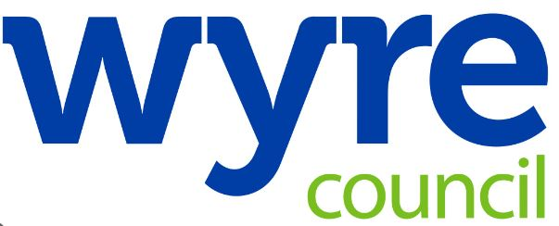

Civic Centre
Breck Road
Poulton-le-Fylde
FY6 7PU

24 July 2024

Dear resident,

We are writing to inform you that an investigation is underway linked to potential contamination from the AGC Chemicals Europe, Ltd. plant at Hillhouse Technology Enterprise Zone in Thornton Cleveleys.

Working with a range of agencies, Wyre Council has determined that a detailed investigation should be carried out under Part IIA of the Environmental Protection Act 1990. At this stage the investigation has been launched to consider whether contamination has occurred in the first instance and, if it has, to what extent.

The issue relates to historic use of a chemical called PFOA which was used on the AGC Chemicals site between the 1950s and 2012. The use of this substance was within the terms of AGC Chemicals’ permit, issued by the Environment Agency, and also in line with UK legislation in place at the time.

However, in 2019, PFOA was added to the Stockholm International Convention on Persistent Organic Pollutants and last year it was classified as carcinogenic to humans by the International Agency for Research on Cancer (IARC).

Wyre Council will use scientific information and data gathered during the investigation to determine whether any land should be officially classified as contaminated under the Part IIA provisions.

Current public health advice from UK Health Security Agency (UKHSA) for people living around or on potential contaminated land sites is aimed at reducing contact with the soil by taking sensible measures.
This advice states local residents should:
- Continue to enjoy using your garden space as you normally would
- Follow normal hygiene precautions and wash hands thoroughly after working or playing in the garden or allotment, especially when in contact with soil and before handling food, drink
- Wash and peel any produce grown in the soil in order to remove any soil or dust
As more data is gathered during the investigation, the relevant agencies will work together to develop any further guidance as required.
As a council, the community is at the heart of everything we do and we therefore want to uphold our duty of transparency and to make sure residents understand what is happening and why.

We know people are likely to have questions and concerns about the investigation. We will be adding helpful information to our website when possible so it would be a good idea to check this regularly to see if we can answer any further questions there. The webpage address is: www.wyre.gov.uk/multi-agency An email address has also been set up to receive questions about the investigation: multi-agency@wyre.gov.uk

We hope that this information, and the information contained on the webpage, is helpful to you.

Yours sincerely,

Rebecca Huddleston

Chief Executive, Wyre Council

